**ASSIGNMENT#2 -REPORT**

**Group Member 1:**

**Group Member 2:**

1. **Menu (8 pts):** The program must have a menu that enables the user to select the required operation. Your program must do the operations between instruction 3 and instruction 8.

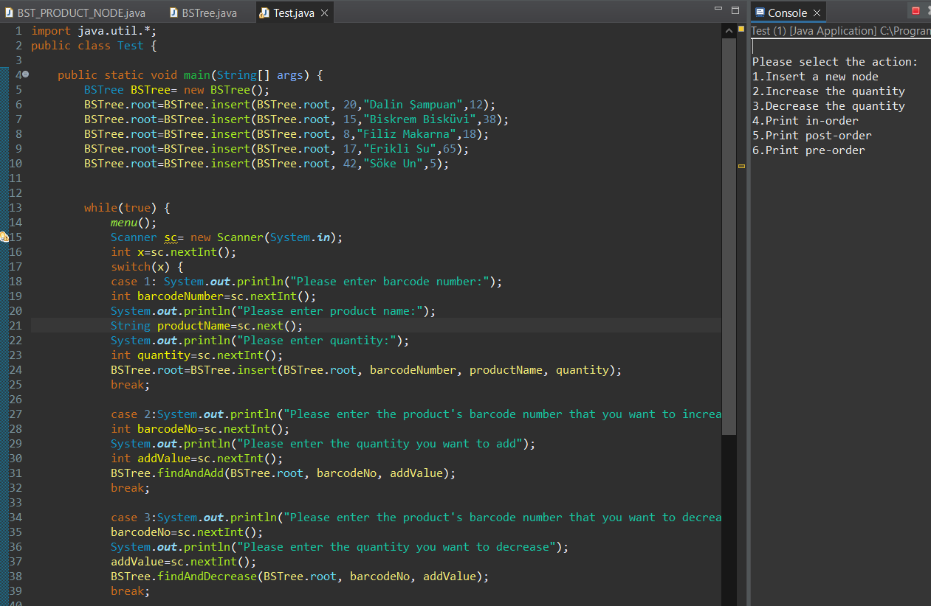

1. **Insert a new node (20):** If user selects this operation; she/he is prompted to enter barcode number, product name and product quantity properties. The product record is added to the tree sorted due to the barcode number. If you examine the sample illustration in Figure 2, all records are placed numerically ordered due to the barcode number.

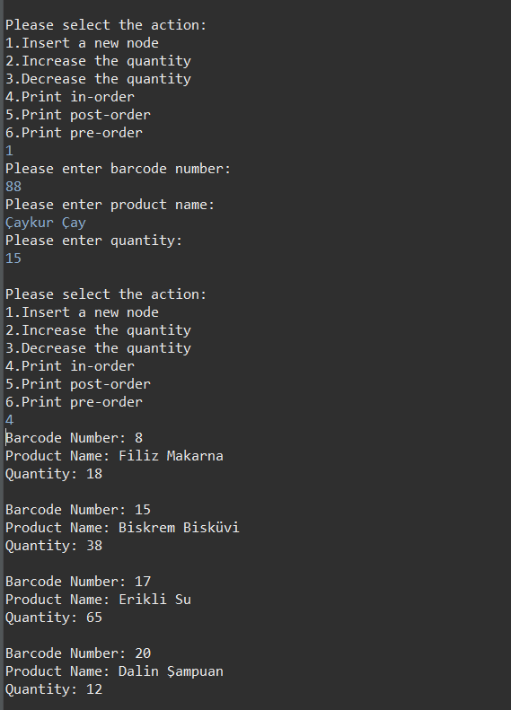

1. **Increase the quantity (15):** If user selects this operation, she/he is prompted to enter the barcode number and the increment amount. The quantity of the corresponding product is increased by the input amount and updated. The records are printed in order traversal.

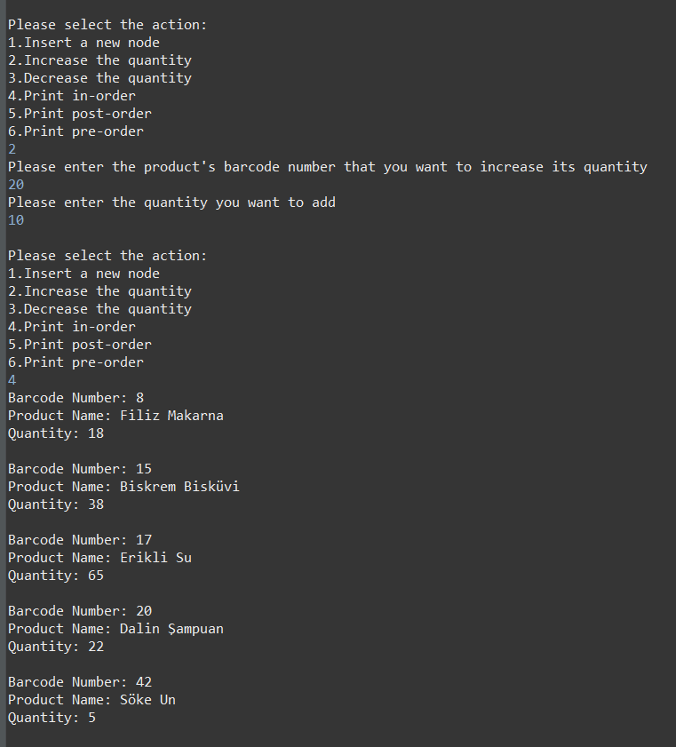

1. **Decrease the quantity(15):** If the user selects this operation, she/he is prompted to enter the barcode number, and the decrement amount. The quantity of the corresponding product is decreased by the input amount and updated. The records are printed in order traversal.

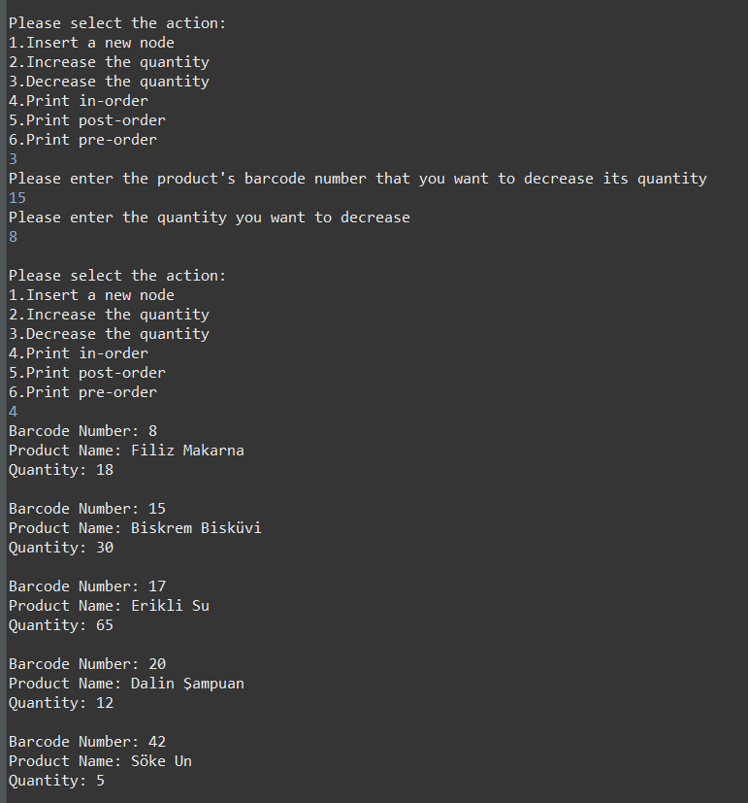

1. **Print in-order (8 pts):**

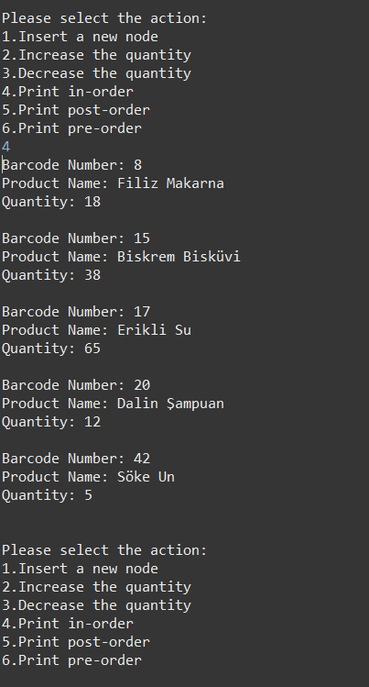

1. **Print post-order (8 pts):**

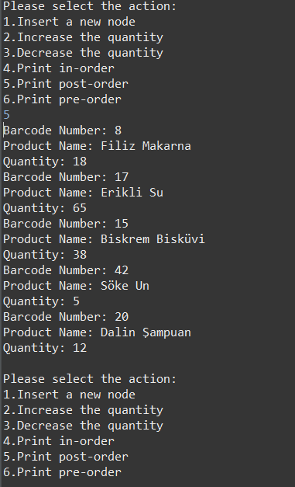

1. **Print pre-order (8 pts):**

